**Web and & Development**

**TAUHA**

**Roll no: 203080**

Visual Studio Code installed:

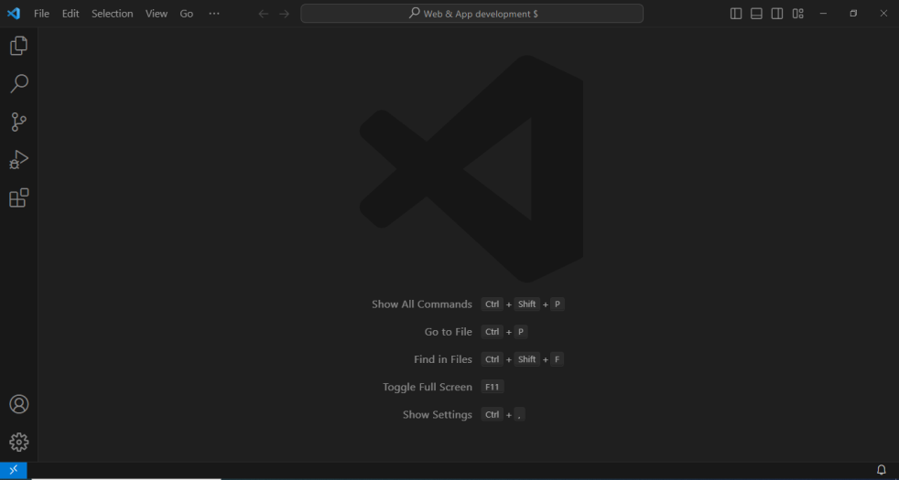

Boiler plate code:

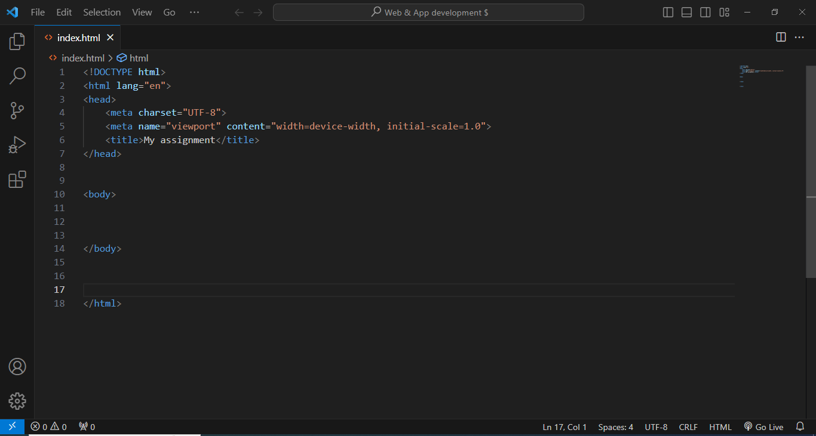

Using some tags:

